|  |
| --- |
| Revolutionary War Unit |

**VS.5 a-c**

**The student will demonstrate knowledge of the role of Virginia in the American Revolution by:**

1. identifying the reasons why the colonies went to war with Great Britain as expressed in the Declaration of Independence.
2. identifying the various roles played by whites, enslaved African Americans, free African Americans, and American Indians in the Revolutionary War era, including George Washington, Thomas Jefferson, Patrick Henry, and James Lafayette.
3. identifying the importance of the Battle of Great Bridge, the ride of Jack Jouett, and the American victory at Yorktown.

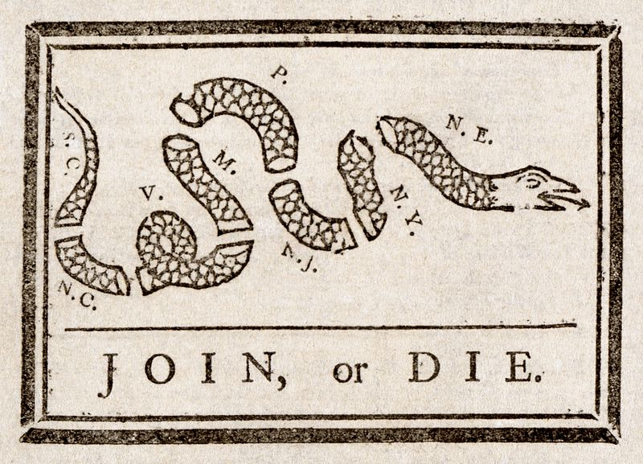

|  |
| --- |
| Causes of the Revolutionary War |

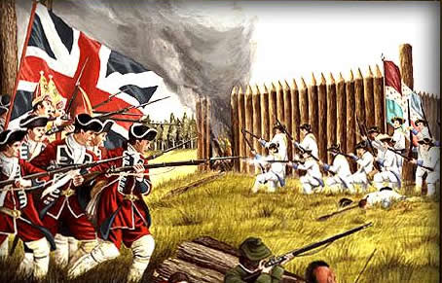In 1754 there were 13 rapidly growing British colonies along the Atlantic coast. The growing colonies were expanding westward into the Ohio River Valley which was claimed by the French. Fighting soon broke out between France and Great Britain with the American Indians becoming involved with both sides as well. This war became known as the **French and Indian War** and lasted from 1754 to 1763. George Washington started his military career during this war and gained experience that helped during the future war with Great Britain.

The French did very well at the beginning of the war and had several victories. It helped that most of the American Indians had sided with the French. The French were primarily interested in trading with Indians and were not starting large settlements that took over Indian land like the British colonies. Great Britain’s poor start to the war frightened the King and he started spending more money. In the end, Great Britain was victorious, but they had paid large amounts of money to win the war.

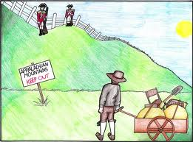After the war, the colonists were ready to settle the land in the Ohio River Valley that they had fought for. Great Britain’s king did not want any more trouble with the American Indians, so he issued the **Proclamation of 1763**. This banned colonists from settling anywhere west of the mountains. The colonists were outraged and deliberately disobeyed the King by settling there anyway.

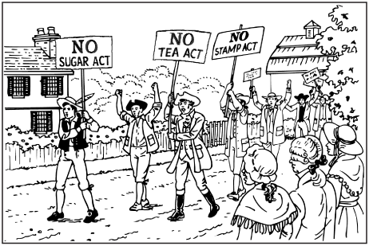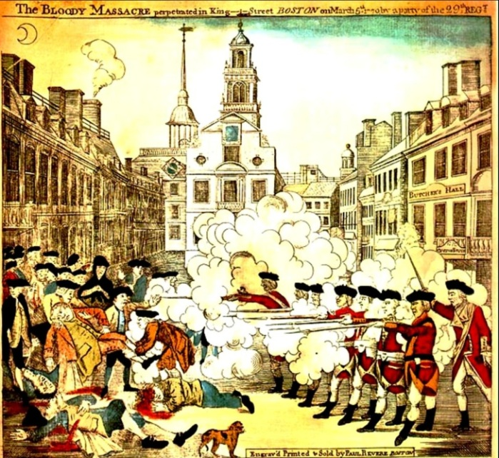Several new tax laws were passed and enforced in the colonies to try to repay the debt from the war. A **tax** is money that citizens are *required* to pay their government. The laws passed required the colonists to pay a tax to get married, buy land, or print a newspaper. Other laws forced colonists to pay a tax when they bought things like paint, glass, paper, or tea from England. If they didn’t pay their taxes, the colonists would be punished. Soldiers were sent to the colonies to keep order.

On March 5, 1770, in Boston, Massachusetts, a fight broke out between a mob of colonists and British soldiers. The fight, known as the **Boston Massacre** resulted in the deaths of five colonists and the wounding of six with the British soldiers suffering no fatalities. This event angered not only those in Boston, but colonists in the other colonies up and down the Atlantic Coast.

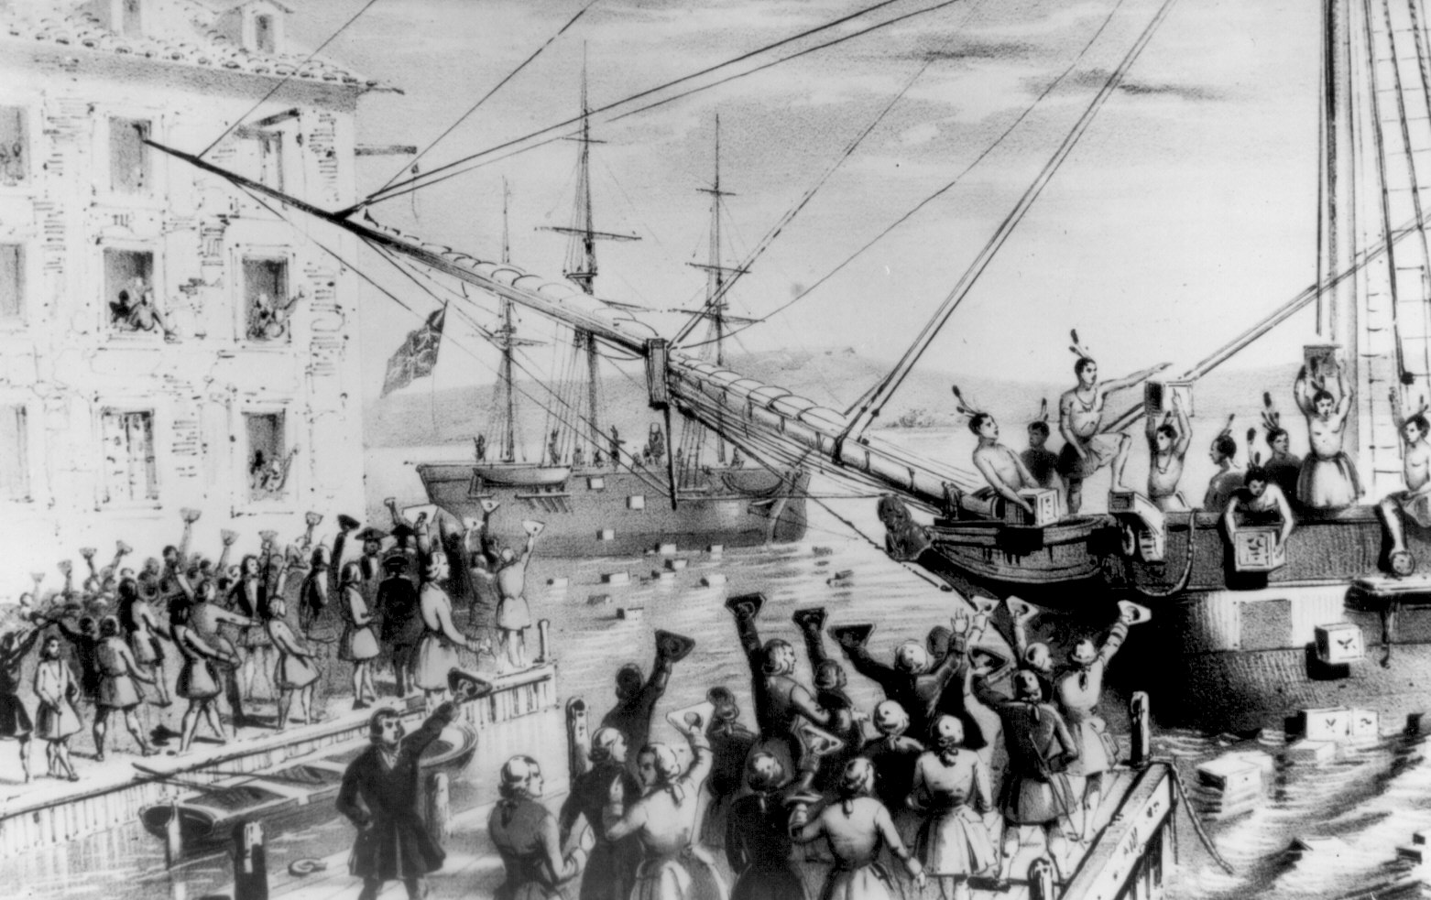Then on December 16, 1773, some colonists, disguised as Indians stormed aboard three ships carrying tea into Boston Harbor. They tossed 342 chests of tea into the water. This event is known as the **Boston Tea Party** and it angered Great Britain. These events and others led to the start of the Revolutionary War.

|  |
| --- |
| Disagreements with Great Britain |

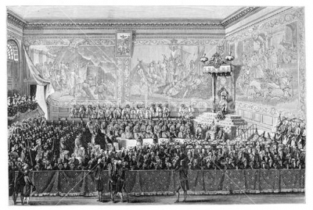 Conflicts developed between the colonies and Great Britain over how the colonies should be governed. **Parliament**, the British lawmaking body, believed that it had legal authority in the colonies while colonists believed that their local governments, or assemblies (like the Virginia Assembly) had legal authority. The House of Burgesses declared that the Virginia Assembly was the only lawmaking body with the authority to tax Virginians. They also stated that colonial courts would decide when laws had been broken, not courts in England.

Parliament also believed that it had the right to tax the colonies. The colonists believed they should not be taxed since they had no representation in Parliament. This made the colonists very angry because they had no say in the decisions that Parliament made about taxing the colonies.

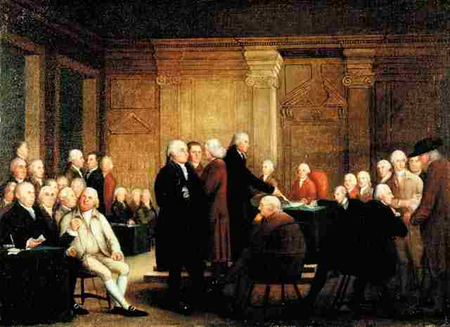In September of 1774 representatives from 12 of the 13 colonies met in Philadelphia, Pennsylvania. This important meeting was known as the First Continental Congress. The Congress asked the king to repeal all of the unfair laws and give the colonists the rights and freedoms of English citizens. King George did not respond and many colonists began to talk of war.

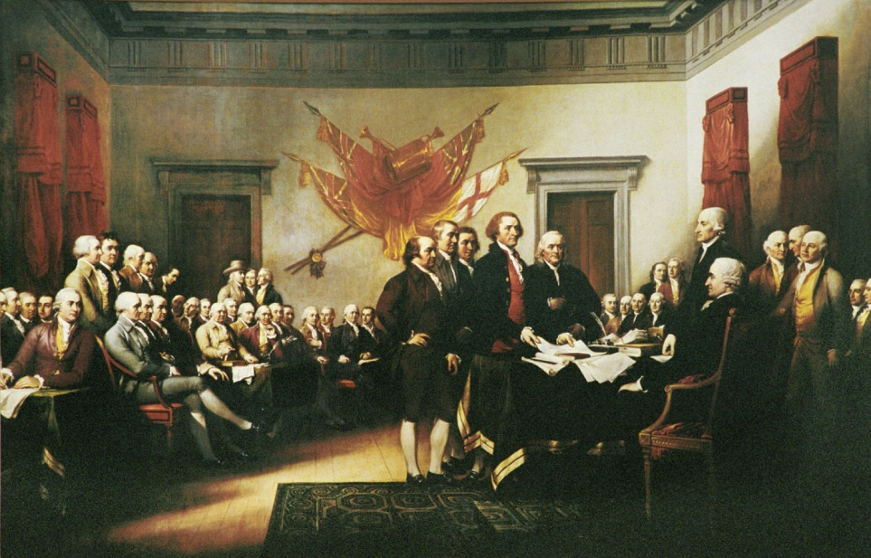The first shots of the war rang out in Concord, Massachusetts in April of 1775. In May of 1775, as the fighting continued, the Second Continental Congress met to declare that the colonies were free and independent states. They wrote a document called the **Declaration of Independence**, which expressed the reasons for colonial independence from England. It declares that the authority to govern belongs to the people rather than to kings. It also states that all people are created equal and have rights to life, liberty, and the pursuit of happiness. It was adopted by the Continental Congress on July 4, 1776. The fourth of July is our country’s birthday and the day we celebrate our independence.

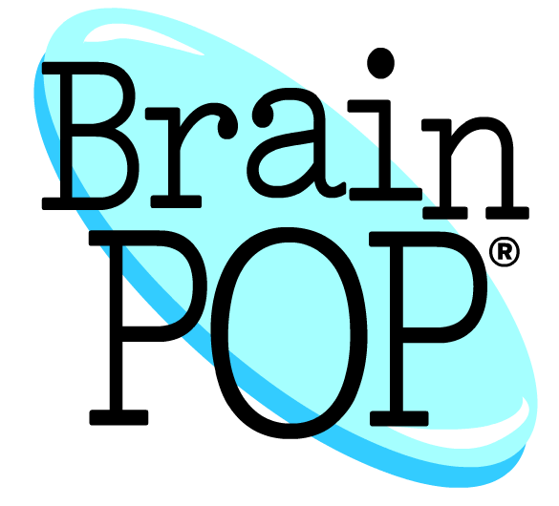

**-------------------------------------------------------------------------------------------**

|  |  |
| --- | --- |
| http://weloverocknpop.com/wordpress/wp-content/uploads/2012/04/versus.png**British Parliament believed…** | **Colonists believed…** |
|  |  |
|  |  |

**Directions: Draw pictures in boxes to represent words.**

The Declaration of Independence states that the authority to govern belongs to the rather than to . It also states that all people are created and have rights to life, liberty, and the pursuit of .

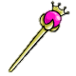C:\Users\Jenny\AppData\Local\Microsoft\Windows\Temporary Internet Files\Content.IE5\44GQSBKD\MC900237940[1].wmfThe King’s Candy

There will be one king, two members of Parliament, two tax collectors, and the rest of you will be colonists.



The King, Parliament, and the tax collectors will stand in the front of the room. Parliament will take turns drawing the tax cards and reading them to the class. If the card describes you, you must pay the tax that it requests. After each card is drawn, the tax collectors will go around the room and collect from each student who needs to pay.

When all taxes have been paid, Parliament will divide the taxes up between them, the tax collectors, and the King. The King will get ½. Parliament gets ¼ to divide between them and the tax collectors get ¼ to divide between them. The colonists may have whatever they have left.

Part A: Pre-Activity

**1.** What role were you given? ______________________

**2.** How do you think you will do in this activity knowing what role you were given? Explain your response. _________________________________________________ ___________________________________________________________________

Part B: Simulation

**3.** How many pieces of candy do you have at the beginning? ____________________

**4.** How many pieces of candy do you now have at the end? _____________________

Part C: Reflection

**5.** How did this activity make you feel? ____________________________________ ___________________________________________________________________ ___________________________________________________________________

**6.** Do you think the taxes in this activity were unfair? Why? ____________________ ___________________________________________________________________ ___________________________________________________________________

**7.** How do you think the colonists felt about the taxes they paid? ________________ ___________________________________________________________________ ___________________________________________________________________

___________________________________________________________________

8**.** If you were a colonist, would you have agreed with declaring independence from Great Britain? Why or why not? _________________________________________ ___________________________________________________________________ ___________________________________________________________________

___________________________________________________________________

___________________________________________________________________

|  |
| --- |
| American Revolution: Choosing a Side |

During the American Revolution, the American colonists had to decide to support the War for Independence or remain loyal to the British and King George III. Some Americans could not decide which side to choose and remained **neutral** during the war. Most American colonists, however, did choose sides.

Those who supported independence from Britain were known as **Patriots**. Most Patriots supported independence because they felt that recent British laws on the American Colonies took away their rights as British citizens. They were against taxation without representation. A patriot soldier would be part of the **Continental Army**.

Colonists who opposed independence from Britain were known as **Loyalists**. Most Loyalists who opposed independence usually had close connections to Britain. Many Loyalists agreed that the American colonists had been mistreated by the British, but Loyalists hoped that they could make peace with the British government. They were worried that the colonies would be weak without protection and support from the British.

Those living in the American colonies had lots of different reasons for choosing their side. Tenant farmers often chose their position on the Revolution based on which side their landowner supported. For example, if a Patriot landowner was cruel and always raised the rent, the tenant would be a Loyalist, but if the Patriot landowner was kind and collected a fair rent, the tenant would be a Patriot. Colonists who owed money to the British often became Patriots since they hoped winning the Revolution could get them out of paying back that money. There were many different reasons for choosing your side in the war.

Text modified from: <http://www.converse.edu/sites/default/files/site-files/Academics/NEH/PatriotLoyalistorNeutral_YouDecide.pdf>

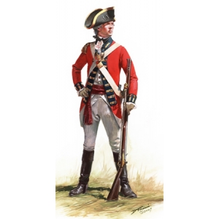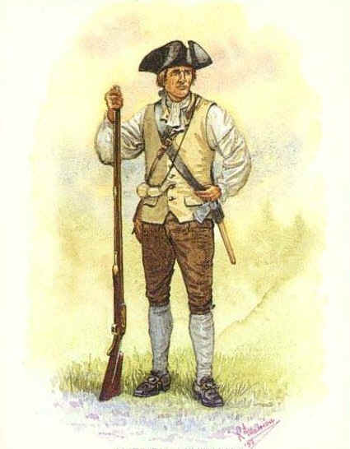

Patriot

or

**Loyalist?**

Directions: Color the statement **BLUE** if a patriot would say it. Color it **RED** if a loyalist would say it.

|  |  |
| --- | --- |
| “We need Great Britain to protect us if someone attacks the colonies.” | “King George is an unfair ruler! He allows Parliament to tax us without our say.” |
| “Our local assemblies have legal authority in the colonies, not parliament.” | “I think that we can make peace  with the British government.” |
| “We are British subjects and  should obey their laws.” | “I will fight in the Continental Army!” |
| “Parliament has legal authority  in the colonies.” | “British laws on the American colonies  are taking away my rights.” |
| “No taxation without representation!” | “Colonists don’t have a say in British Parliament, so we shouldn’t be taxed.” |

|  |
| --- |
| Roles of Virginians during the Revolutionary War |

In Virginia, there were colonists on all different sides of the conflict – patriot, loyalist, or neutral. It didn’t matter what the color or your skin was or whether you were a man or woman, each individual person had a unique and personal reason for their decision of which side to support.

If you were a patriot living in Virginia, you may have been a soldier fighting for independence from Great Britain in the **Continental Army**. You did not need to serve in the army to be a patriot though. Many Virginians that sided with the patriots helped the war effort from home. They donated food and other supplies to the war effort. If you were a loyalist living in Virginia, you could have supported the British cause either as a soldier or plain citizen. Virginia and Massachusetts led the way for the colonies during the war, so there were not many loyalists living in Virginia. Most loyalists lived in New York which was a loyalist stronghold. Still there were some Virginians that were neutral and did not take sides. Many neutral Virginians lived further out, far away from the conflict of the war and preferred to stay as uninvolved as possible.

Women took on more responsibilities to support the war effort. They drove wagons, rode with army supply trains, made gunpowder, sewed and repaired uniforms for the troops, and worked as nurses and cooks. Even the women who remained at home contributed to the war. These women ran their family farms and grew food for those on the battlefields.

Some enslaved African Americans fought for a better chance of freedom. As the Revolutionary War spread through every region, enslaved African Americans sided with whichever army promised them personal liberty. Some free African Americans fought for independence from Great Britain. Many American Indians living in Virginia fought alongside the Virginia patriots, while others fought with the British.

|  |
| --- |
| Roles of Virginians during the Revolutionary War |

|  |  |  |  |  |  |
| --- | --- | --- | --- | --- | --- |
| **Whites** | | |  | **African Americans** | |
| Patriots | Loyalists | Neutral |  | Enslaved | Free |
|  |  |  |  |  |  |

|  |  |  |
| --- | --- | --- |
| **Women** |  | **American Indians** |
|  |  |  |

|  |
| --- |
| Famous Virginians during the Revolution |

Virginia was home to many famous leaders that played major roles in the Revolutionary War. **Thomas Jefferson**, a Virginian, provided political leadership by writing the reasons for colonial independence from Great Britain in the Declaration of Independence. He was also the second governor of the independent state of Virginia during the Revolutionary War.

**George Washington** was a Virginia plantation owner who had gained military experience during the French and Indian War. He provided military leadership by serving as commander-in-chief of the Continental Army. Washington’s army was made up of mostly untrained men, from all over Virginia and the other colonies. Washington provided much needed military leadership to the rough, inexperienced colonial troops.

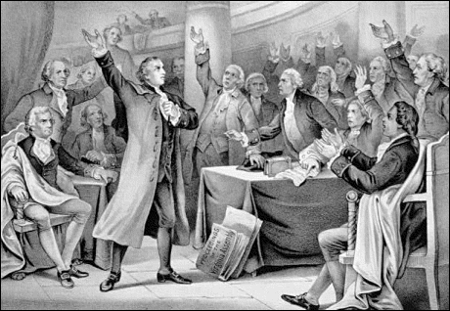Another Virginian by the name of **Patrick Henry** inspired patriots from other colonies when he spoke out against taxation without representation. He believed that war was the only answer to the growing problems with England. In a famous speech in the city of Richmond, Virginia on March 23, 1775 he stated, “Is life so dear, or peace so sweet, as to be purchased at the price of chains and slavery? I know not what course others may take; but as for me... give me liberty or give me death!” Patrick Henry was also the first governor of the independent state of Virginia during the Revolutionary War.

**James Armistead Lafayette**, a slave from Virginia, volunteered to join the Continental army as a spy. His master granted him permission to join the revolutionary cause, and he was stationed to serve under the Marquis de Lafayette, the commander of allied French forces. Posing as a runaway slave hired by the British to spy on the Americans, Armistead successfully gained access to British General Charles Cornwallis' headquarters. He became famous for delivering letters to other spies. At the end of the war he was given his freedom.

- - - - - - - - - - - - - - - - - - - - - - - - - - - - - - - - - - - - - - - - - - - - - - - - - - - - - - - - - - - - - - - - - - - - - - - - - - - - - - - - - - - - - - - - - - - - - - - - - - - - - - - - - - - -Directions: Fill in the space around each famous Virginian with facts from this passage.

|  |  |
| --- | --- |
| Thomas  Jefferson | George Washington |
| Patrick  Henry | James  Lafayette |
| Revolutionary War Events in Virginia | |

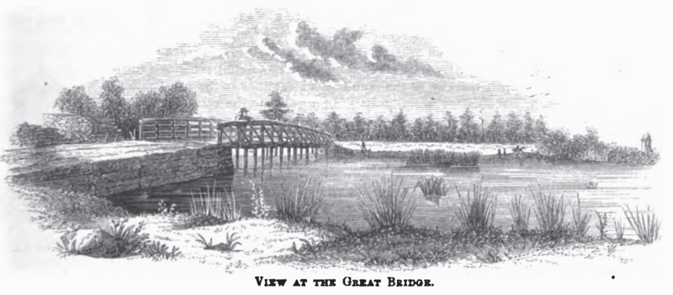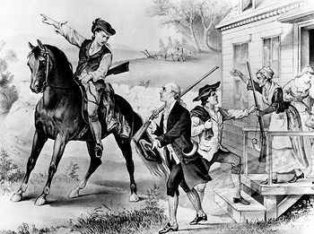On December 9, 1775, seven months before the Declaration of Independence, the first land battle of the American Revolution fought in Virginia took place near Norfolk. It was known as the **Battle of Great Bridge**. This battle resulted in between 62-102 British losses with only one patriot suffering an injury in the hand. The victory by the Continental Army forced the British governor, Lord Dunmore, to flee the City of Norfolk. He fled to a British ship and ordered Norfolk to be destroyed. This caused many loyalists in Virginia to join the patriot’s side. Lord Dunmore was loyal to Great Britain and his departure marked the end of British power in the colony of Virginia. Patrick Henry became Virginia’s first governor as a free and independent state.

Later, in June of 1781 another important event occurred in Virginia. At this time, Thomas Jefferson was then serving as the second governor of Virginia. On the night of June 3, 1781, Thomas Jefferson, Patrick Henry and some other important Virginians were at Jefferson’s home in Charlottesville. A man named **Jack Jouett** was in the town of Louisa. He overheard some British soldiers talking about capturing Jefferson and the others. He rode on horseback from Louisa through the backwoods of Virginia to Charlottesville to warn Thomas Jefferson. The trip was over 30 miles! He warned them that the British were coming to arrest him and members of the General Assembly. Jefferson and the others were able to escape.

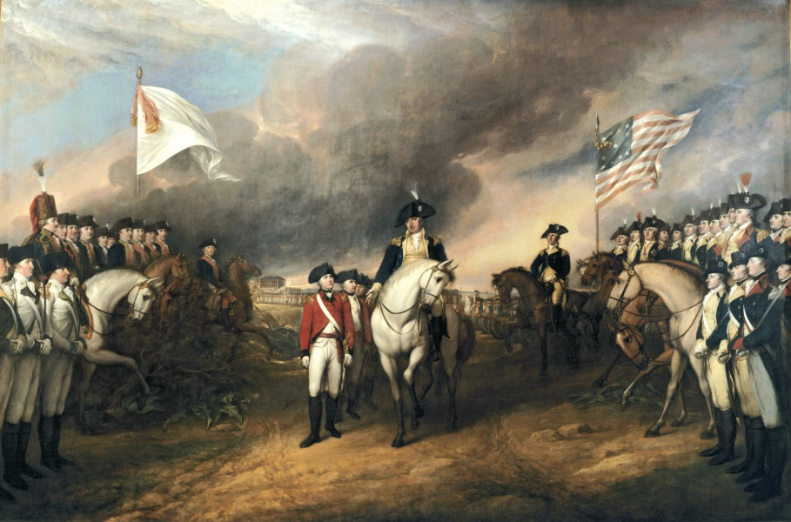The Revolutionary War between the 13 colonies and Great Britain ended on October 19, 1781 at Yorktown, Virginia. The **Battle of Yorktown** was a combined effort of both George Washington’s Continental Army of 8,800 and 7,800 French allies against a British army of 6,000. This American victory resulted in the surrender of the British Army. After six long years of fighting, the English general Cornwallis surrendered to the Continental Army at Yorktown.

Comic Strip

Directions: Illustrate a comic strip for one of the three Virginia Revolutionary War events.

|  |  |
| --- | --- |
|  |  |
|  |  |

|  |
| --- |
| The War is Over! …Now What? |

After the surrender of the British at the Battle of Yorktown, Virginia and the other 12 colonies were freed from British rule. What kind of problems do you think Virginians and other colonists faced after the war? What did the colonists need to do now that the war was over?

- - - - - - - - - - - - - - - - - - - - - - - - - - - - - - - - - - - - - - - - - - - - - - - - - - - - - - - - - - - - - - - - - - - - - - - - - - - - - - - - - - - - - - - - - - - - - - - - - - - - - - - - - - - -

Directions: Brainstorm a list of problems that colonists may have faced after the war.

Problems faced by colonists after the war:

* __________________________________________________________________________________
* __________________________________________________________________________________
* __________________________________________________________________________________
* __________________________________________________________________________________

Directions: Brainstorm a “To Do” List to solve some of the problems you came up with.

To Do List:

* __________________________________________________________________________________
* __________________________________________________________________________________
* __________________________________________________________________________________
* __________________________________________________________________________________

Revolutionary War Events Timeline Activity

1. Find the dates in your notes for the following events. (Not all have EXACT dates)
2. Put the events in order #1-11 putting numbers in the first column.
3. Write a quick description of each event in the “What Happened?” column.

|  |  |  |  |
| --- | --- | --- | --- |
| **#** | **Event** | **What Happened?** | **Date** |
|  | French and Indian War |  |  |
|  | Boston Massacre |  |  |
|  | Boston Tea Party |  |  |
|  | First Continental Congress |  |  |
|  | First Shots of the War |  |  |
|  | Second Continental Congress |  |  |
|  | Declaration of Independence |  |  |
|  | Patrick Henry’s Speech |  |  |
|  | Battle of Great Bridge |  |  |
|  | Jack Jouett’s Ride |  |  |
|  | Victory at Yorktown |  |  |